Aim: Execute the flowing Linux commands: touch, echo, clear, ls, dir, mkdir, cat, rmdir, rm, cp, mv, head, tail, wc, sort.

# Requirements:

* Linux operating system
* Terminal

# Step 1: Go to the Linux operating system, open the terminal and follow the cmd.

**touch-**

**input:**

## **touch p1.txt**

Touch cmd use to create a blank txt file.

**Output:**

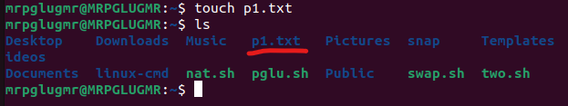

**echo-**

**input:**

**echo hi how are you**

**this cmd used for print some this**

**Output:**

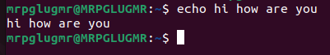

**clear-**

**input:**

**clear**

**use to clean the terminal (recants cmd)**

**Output:**

**Before**

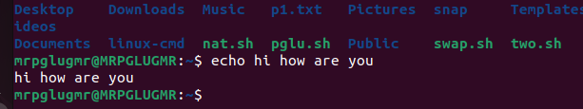

**After**





**ls-**

**input:**

**ls**

**ls use for list the all file.**

**Output:**

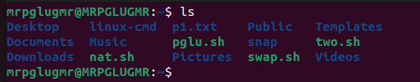

**dir-**

**input:**

**dir**

**show the all directory**

**Output:**

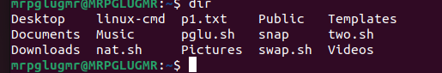

**mkdir-**

**input:**

**mkdir p2.txt**

**mkdir cmd use fro creating a new directory file.**

**Output:**

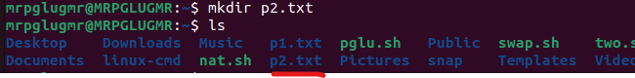

**cat-**

**input:**

**cat> p3.txt**

**cat cmd use for create a new txt file with contain.**

**Output:**

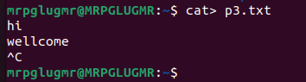

**input:**

**cat p3.txt**

**use to shoe what in side.**

**Output:**

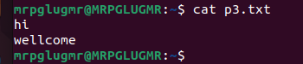

**rmdir-**

**input:**

**rmdir p2.txt**

**we are creating a directory p2.txt know we are removing.**

**Output:**

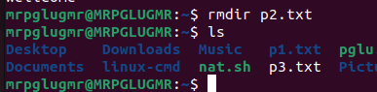

**rm-**

**input:**

**rm p3.txt**

**this cmd used to remove a txt file.**

**Output:**

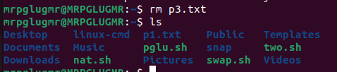

**cp-**

**input:**

**cp p1.txt p2.txt**

**we are creating two files p1.txt and p2.txt. here p1 have a data but p2 don’t have any data know we are copy the data to p2.txt file.**

**Output:**

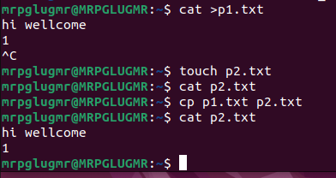

**mv-**

**input:**

**mv p1.txt p3.txt**

**know we are creating a txt file and move the p1.txt data to p3.txt**

**Output:**

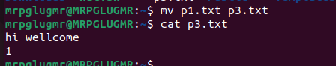

**head-**

**input:**

**head pglu.txt**

**head show the top 10 lines.**

**Output:**

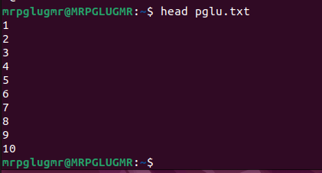

**tail-**

**input:**

**tail pglu.txt**

**tail show the last 10 line.**

**Output:**

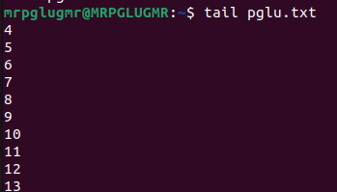

**wc-**

**input:**

**wc pglu.txt**

**wc use to count the no of words.**

**Output:**



**sort-**

**input:**

**sort mr.txt**

**sort cmd use for arranging the data by (A-Z).**

**Output:**

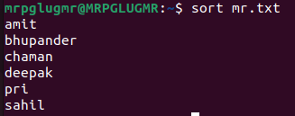

**input:**

**sort -r mr.txt**

**used to (Z-A)**

**Output:**

